Parent Handbook

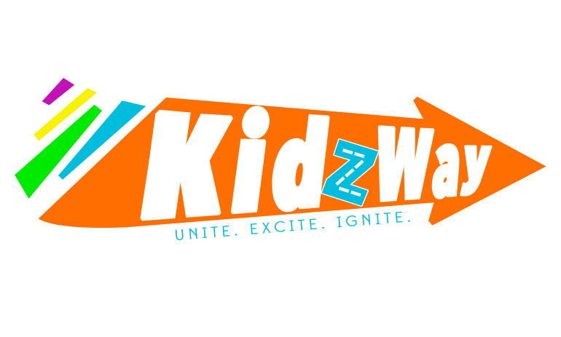
KIDZWAY
Mission
Statement:
Unite-Families
Excite- Kids
Ignite-Their Love for Jesus!

mandy.rhodes@cwc.life
tammy.draper@cwc.life
nathan.rehm@cwc.life
lori.schramp@cwc.life
Thank You for Partnering with us this Year!

We consider it a great privilege to be a part of discipling our next generation.

Blessings,

The KIDZWAY Team

Mandy Rhodes- KIDZWAY Director

Tammy Draper- Early Childhood Director

Nathan Rehm- Elementary Director

Lori Schramp- KIDZWAY Secretary

TABLE OF CONTENTS
Room Ages/Grade………………………………………………………………………………………3
Parent Expectations……………………………………………………………………………………………4-5
KIDZWAY Procedures………………………………………………………………..……………..6-8
Sample Schedule- Preschool………………………………………………………………………11
Sample Schedule- Elementary……………………………………………………………………12
KIDZWAY Policies…………….……………………………………………………………………………….…12-14
Preschool Policies………….…………………………………………………………………...……..15
Emergency Evaluation Procedure………………………………………………………………16
Other KIDZWAY Events…………………………………………………………………………...…17

Rooms and Ages/Grades

Sunday Morning

Adventure Alley- Preschool
Aquarium Room- 9 months- 20 months
Circus Room- 21 months- Potty Trained
Safari Park- Potty Trained- 3 years

Firestation- 3 years by 10/31/2016

Airport- 4 years by 10/31/2016 – Not yet enrolled in Kindergarten

Town and City- Elementary Kindergarten-5th

Town Park- Kindergarten
Town Square- 1st and 2nd Grade
KIDZWAY City
3rd and 4th Grade
5th Grade

Parent
Expectations

WHAT IS EXPECTED OF YOU AS A PARENT
PARTNERSHIP
- WE ASK THAT YOU BE PLACED ON A PARENT ROTATION TO SERVE WITHIN KIDZWAY. IF YOUR CHILD ATTENDS KIDWAY, WE ASK THAT YOU PARTNER WITH US AND SERVE! PLEASE FILL OUT THE ATTACHED PAPERWORK AND CONNECT WITH A KIDZWAY STAFF MEMBER TO LEARN MORE ABOUT SERVING.
PUNCTUALITY
- WE ASK THAT YOU ARE ON TIME DROPPING OFF AND PICKING UP YOUR CHILD FROM KIDZWAY.

DROP OFF TIME

- FOR YOUR CHILD’S SAFETY, YOU ARE RESPONSIBLE FOR ESCORTING YOUR CHILDREN TO THE CLASSROOM DOOR.

ALLERGY ALERT!

- PLEASE LET US KNOW (EVERY WEEK) OF YOUR CHILD’S ALLERGIES AS OUR TEACHER ROSTER ROTATES FREQUENTLY. THERE WILL BE AN ALLERGY WRIST BAND FOR YOUR CHILD TO WEAR EACH WEEK. (LOCATED AT CHECK IN)

ON CAMPUS POLICY
- YOU ARE REQUIRED TO STAY ON CAMPUS FOR THE ENTIRE DURATION OF SERVICE, WHEN YOUR CHILD IS ATTENDING KIDZWAY PROGRAMMING.

Procedures

Doors Open 8:45 AM- 1st Service
Doors Close at 9:15 AM-1st Service
Doors Open 10:30 AM- 2nd Service
Doors Close 11:00 AM- 2nd Service
FIRST TIME CHILDREN
- Please stop at the first time check in desk, located in the foyer. You will be asked to fill out an information card.
- Your child will receive a special sticker to help our teachers know that it is their first time.
- You will also receive a KIDZWAY card to use at the start of your second visit at KIDZWAY. This card can be used to check in at our self-check in kiosk.
- Please be sure to let the registration team know of any allergies your child may have. You are also responsible for letting the teacher know, every week, if your child has an allergy, as our teachers do rotate frequently.
CHECK IN
- All children are required to check in before entering KIDZWAY.
- CHECK-IN STATIONS: Will be open from 8:45 to 9:15 (1st service) and from 10:30 to 11:00 (2nd service).
- If you need your child after the doors have closed, please go to the HUB and a security team member will escort you to KIDZWAY.
ALLERGIES
- Due to the high volume of children with allergies in KIDZWAY, we ask that NO OUTSIDE FOOD be brought into the KIDZWAY area.
- KIDZWAY staff will provide snacks that are approved for our children with allergies. For a complete list please see a KIDZWAY staff member.
CHILDREN STAYING TWO SERVICES
- If you attend a group or serve in an area of ministry at CWC your child may stay for two services.
- If your child is staying two services, you must fill out a two service sticker, so that we know where to reach you, each service, in case of an emergency.
5TH SUNDAY FAMILY WORSHIP
- On months that have a 5th Sunday in it, we ask that 3rd, 4th, and 5th Grade children attend main service for Family Worship.
- We believe that our older KIDZWAY kids need to be included in the Worship experience with the entire congregation to become familiar with our Pastors, Congregation, and Worship here at CWC.
- This occurs four times a year.
- There is still programming for ages 9 months- 2nd Grade.
DIAPER POLICY
- Please be sure that your child has a clean/dry diaper before entering KIDZWAY classrooms.
- We will page you if your child has had an accident, or needs further assistance.
DRESS CODE
- Because KIDZWAY is a high energy environment and children will be playing and sitting on the floor, we ask that girls wear shorts or leggings under their dresses.
- PLEASE refrain from any inappropriate language/images on clothing.
PICK-UP POLICY
- Please make sure that you have your ticket ready for the teacher, when you pick up your child.
- If have you have lost your child’s claim ticket, you must fill out the necessary form in order to pick up your child. The teacher will provide the form for you.
- If a child loses their name badge, we will allow parents to pick them up as long as they show their pick-up tag.
- Please notify KIDZWAY staff if there are any individuals that are NOT authorized to pick up your child.
*Children must be picked up by a parent or someone authorized by their parent/guardian.
ADULTS IN CLASSROOMS
1. For security purposes, only members of the KIDZWAY team will be allowed in the classrooms.
(*We run a background check for all adults in our classrooms.)
*The only exception is if a child is new and their parent would like to stay and observe. If observing, the adult must wear a guest badge, sign in, and will not be authorized direct contact with any other child except their own.
SUMMER’S IN KIDZWAY
- We run a special Summer Series (June-August) for our KIDZWAY kids.
- Guest Speakers are invited to come and share their gifts while still sharing the Gospel.
- We ask that parents help during the summer months. This gives our faithful volunteers a chance to travel or join a group at Church during the summer.
- Our Summer Series is an excellent time to be involved, build relationships with our KIDZWAY kids, and serve the Kingdom!
- Look for Summer sign-ups beginning in April.
Promotion Sunday (when ALL children change rooms) will occur every year on the Sunday following Labor Day. Please be prepared to update your family’s information.

Example Service
Schedules

Adventure Alley Planner
The times are given only as a guideline

Date | 10/23/2016
Bible Story Focus | Lesson 8
Opening  8:45 – 9:15 1st  10:30 – 11:00 2nd | Drop off/Pick up/Free Play  Please have children wash hands as they enter the room  Circus Room – use baby wipes
Clean Up  9:15 – 9:20 1st  11:00 – 11:05 2nd | Please have children pick up toys and line up for worship
Worship Time  9:20 – 9:30 1st  11:05 -11:15 2nd | Please transition the children to KidzWay City for worship
Bible Story  9:30 – 9:35 1st  11:15 - 11:20 2nd | Please use your flip chart to teach the lesson  Lesson 8 – God is, God was, and He will be forever.
Memory Verse  9:35 – 9:40 1st  11:20 - 11:25 2nd | Go over motions – refer to poster  Forever, O Lord, Your Word is settled in Heaven. Psalm 119:89
Activity/Circle Time  9:40- 9:45 1st  11:25-11:30 2nd | Please select 2 more circle time activities.
Snack Time  9:45 – 10:00 1st  11:30 – 11:45 2nd | We are trying to move away from hand sanitizer. Please have kids wash hand at sink. This can take a while, but that is OK. Circus Room use baby wipes. Have them go find their seat at the table. Have them sing or say a prayer. Our hands we fold our heads we bow so we can talk to God just now. Thank you God for our friends that are here today and for our snack. Pass out napkins, snacks, and cups of water
Craft Time  10:00 – 10:15 1st  11:45 -12:00 2nd | Create your own craft - children will use various craft supplies to make their “own” creation
Pick up  10:15 – 10:30 1st  12:00-12:15 2nd | Please match the tags with each child that is being picked up. Remind each child that you are happy they were here today.

Example Service Schedule – Kindergarten- 5th Grade

Elementary Schedule: TOWN AND CITY

8:45- 9:15 AM: Play with a Purpose
Parent drop-off and purposeful connection and activity time with children

9:15-9:25 AM Worship

9:25- 9:40 AM Large Group Time

9:45- 10:10 AM- Small Group Time

10:15- 10:30 AM- Prayer and Parent Check Out

Policies

KIDZWAY POLICIES
1. BACK ENTRANCE TO KIDZWAY
- Other than KIDZWAY volunteers and security, NO ONE may use any other entrances/exits to KIDZWAY.

2. PAGING PARENT PROCESS
- KIDZWAY staff will page:
- If a child is injured
- If a child is crying for 15 minutes, without relief
- Discipline Issues
  - We use the three strike method in KIDZWAY. The three steps are as follows:
    - We address the behavior (give a warning)
    - We give time for correction. We allow time in a “think about it chair”, if behavior continues.
    - If desired behavior is not achieved, we will page parents to work with us. You may stay in KIDZWAY (with a guest badge) if you feel this would benefit your child.
- Medical Emergencies:
- If a child shows any signs of illness:
  - Health Policy: For the protection of our children and other volunteers, we will not admit anyone with visible signs of illness. Please do not allow your child to attend programming if he/she has had any of the following symptoms within the past 24 hours:
    - Diarrhea
    - Vomiting
    - Body rash with fever
    - Sore throat with fever
    - Colored nasal discharge
    - Severe coughing
    - Pink eye
    - Skin infections
    - Head lice
    - Fever
*Volunteers are not permitted to administer medications
- Paging Number: Each child will have a call number on their name badge (this is why it is important that each child is checked in). If we need to reach you, we will use the Security Code (1JJ) ,on the screens in Church, as seen below. 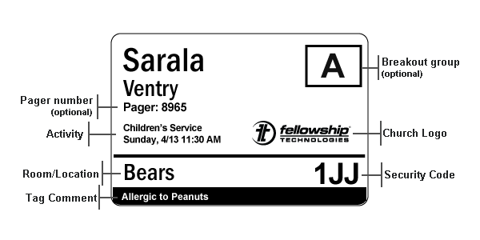

3. INCIDENT REPORTS:
- If an incident occurs, a volunteer will complete the Incident Report form explaining the incident.
- You will be asked to sign the incident form, if your child was involved in the incident.
- A KIDZWAY Director will follow up with you concerning the incident.

4. KIDZ CASH: Used each week in KIDZWAY as our positive reinforcement
- When children earn 20 Kidz Cash (bringing Bible, being nice to a friend, etc.), they tithe two of their Kidz Cash (10%) and then get to shop at:
  - Town: BOB (Basket of Blessings)
  - City: ROB (Rack of Blessings)

- SECURITY TEAM:
The security team provides a physical presence within the facilities and around the property to help ensure its safety.

- CLASSROOM CAPACITY:
For the safety of your child we have implemented the following classroom capacity. Once the capacity is met in each room, you will no longer be able to check in your child in our system.
- Aquarium Room: 12 Children
- Safari Park: 12 Children
- Circus Room: 14 Children
- Fire Station: 18 Children
- Airport: 20 Children
- Town: 40 Children
- City: 40 Children
- FAMILY ROOM
If at any time your little one cannot sit in main service and does not attend KIDZWAY, there is a sitting room located in THE WELL (The Cube seating area) for your convenience.

ADVENTURE ALLEY POLICIES
- SNACKS: Due to food allergies, there are no outside snacks allowed. The snack list provided by KIDZWAY is available upon request.

2. DIAPER TAGS: Please have diaper bags clearly labeled. KIDZWAY labels are available at check in areas and rooms and are to be placed on diaper bags to prevent confusion for our volunteers.
3. DIAPER CHANGING: Please drop off your child with a clean/dry diaper before programming begins.
4. POTTY: If your child is potty trained; please take them to the bathroom before dropping them off at their classrooms.
5. ITEMS: Please be sure that all items are clearly labeled with your child’s name (sippy cups, blankets).
6. OUTSIDE TOYS: We ask that toys be kept at home. Age appropriate toys are provided in each room.

Emergency Evacuation
Procedure

EMERGENCY EVACUATION PROCEDURE:
- KIDZWAY does have an emergency evacuation plan. Evacuation Packets are located in wall pockets in each classroom.
- Instructions:
  - Children will be taken outside using the appropriate exit doors.
  - All KIDZWAY volunteers are equipped to lead children to safety.
  - Parents will be connected with children as soon as the situation is under control. If you would like further information on the emergency evacuation process, please contact a KIDZWAY staff member.

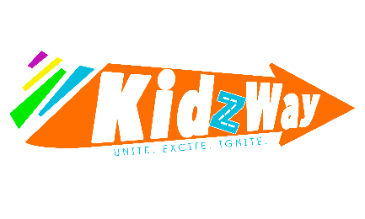
Baby Blessing Class
This class is designed to answer questions about our Baby Dedication process and allow you the opportunity to connect with families that are in the same season of life! You can sign up by contacting lori.schramp@cwc.life
Baby Dedication
All families must participate in the Baby Blessing Class to have your little one dedicated. Contact lori.schramp@cwc.life for Baby Dedication dates.
Baptism
We encourage our youth, who have accepted Jesus as their Savior, to take the next step in their faith walk and be baptized. Contact lori.schramp@cwc.life to schedule a Family Baptism Meeting to learn more.
KIDZWAY Outreach Events
(These are subject to change based on the effectiveness of the Outreach Event)
Trunk or Treat
A Family Friendly- Halloween Alternative! Please no scary costumes! All Ages!
KIDZWAY Camp!
For children who have completed Kindergarten-Completed 5th Grade! Join us in the 3rd Week of June for an experience like no other! Camp is in the evenings from 6:00-8:30 PM
Have other questions about KIDZWAY? We would love the opportunity to chat! Contact any of the KIDZWAY Team Monday, Wednesday-Friday or Sunday. 570.742.8987

