“Go” Bag
For emergency evacuations

Evacuation spot (Sycamore):

If you need to evacuate:

#1: Try to Keep Calm!
Kids will respond as you do.

#2: Line up children.

#3: Have a leader grab the “Go Bag”.

#4: Exit the building and walk to the designated evacuation spot.

Once group arrives at evacuation spot:

#1: Listen to instructions from Safety director.

#2: Keep kids calm.

#3: Stay with your group.

#4: If parents approach, encourage them to stay with the group until Safety Director gives approval for release. Once that occurs, form a line to check out each student, as if they were in the classroom.

Items in this GO bag
(2) Safety Vests (leaders wear)

(2) Walking ropes (KiDS to hold)

- Lighted Safety Cone w/ Batteries
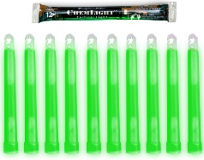
- Spare Set of Batteries

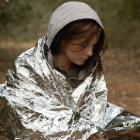
(10) Chemlights (glowsticks)

Emergency Mylar Blankets (1 per child)

Laminated Yellow Sign indicating Room Name(s)
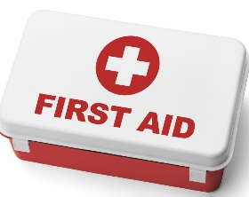

Snacks (1/child)

- First Aid Kit

(5) Ouch Reports
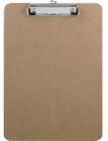
(25)
Missing Tag
Pickup forms

(3) Clipboards/ (20) Pens for class roster & check out
Additional tools in this bag:

- (1) Emergency Procedures Manual
- (1) Laminated Tornado Evacuation Plan
- (1) Laminated Fire Evacuation Route
- (1) Incident Report (for injuries involving medical team)
- (1) Whistle

